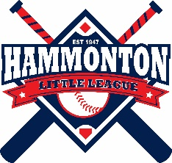 HAMMONTON LITTLE LEAGUE
PO Box 1025, Hammonton, NJ
www.hammontonlittleleague.com
Dave Cappuccio, President Pepe Leo, Vice President
Keith Lowe, Secretary Mark Kozlowski, Treasurer _____________________________________________________________________________________________

NEW BAT REGULATIONS

First, the rule change does NOT go into effect until January 1, 2018, so all current youth baseball bats, which are marked with a 1.15 BPF stamp, will continue to be legal in Little League®, Babe Ruth & Cal Ripken, PONY, Dixie, AABC, and many travel leagues including TSE through December 31st, 2017.
On January 1, 2018 USA Baseball will be implementing a rule change to the bats. If you are 14 years old or younger and play within any of the leagues referenced above, you will need to use a new bat marked with a new USA Baseball stamp. The bats currently on the market, which are marked with a 1.15 BPF stamp, will no longer be legal for play in these leagues.
Additionally, beginning on January 1, 2018, under the new USA Baseball rule, all players 14 and under (not including Tee-Ball) will be able to use approved USA Baseball 2-5/8" barrels in Little League®, Babe Ruth & Cal Ripken, PONY, Dixie, AABC, and other travel leagues such as TSE.
Our understanding is that bats marked with the new USA Baseball stamp will NOT be available for purchase until September 1, 2017. As we get closer to the start of the 2018 season, we will continue to provide updates with additional information, to assist you in the selection/purchase of bats.

